A

Report on

Mushroom Cultivation

Training

Mushrooms are regarded as a macro-fungus with a distinctive fruiting body which can be either epigeous or hypogeous and large enough to be seen with the naked eyes and to be picked by hand**.** Overview of present study is that to evaluate anti diabetic and anti oxidant activities of some of the wild edible mushrooms in which these properties are not studied before or less suited. At first the screening of wild mushrooms will be done by survey, collection and identification of wild edible mushrooms. Then Preparation of spawn and cultivation of selected test mushrooms will be done. molecular taxonomy of selected mushroom species will be done. After that extraction of bioactive compounds from selected mushroom fruiting bodies will be done. Then study the in vivo anti diabetic activities and in vitro anti oxidant activities of selected wild edible mushrooms will done.

Mushrooms are the fleshy sporophores of fungi known to grow in nature on decaying cellulosic materials, dead wood, soil and manure pits. Majority of these fungi belong to the class Basidiomycotina and a few to the class Ascomycotina. Edible fungi under the order Agaricales and the families Agaricaceae, Polyporaceae and Pluteaceae have been under commercial cultivation. The edible mushrooms are delicacy in food and form one of the choicest table dishes. They are rich in protein and an excellent source of vitamins and minerals. Most of the mushrooms have very low starch content and can form an ideal food for diabetic patients. Though, about 2000 species have been reported to be edible,

Mushroom cultivation is one of the largest economically viable commercial operations for bioconversion of lignocellulosic waste into highly acceptable food. Cultivating mushrooms is an ideal income generating activity for landless laborers, unemployed youth and weaker sections of the society in our country. Mushroom is also a perfect health food recommended for use to enrich diet with vegetable protein, vitamins, minerals and fibers.

Our purpose to provide training to different peoples of

* Aastha Angio, Sagar, M.P.
* Institution of Horticulture Department, Sagar, M.P.
* Farmers and villagers of Patharia, Jaitpur, Doma, Kaneradev, Sagar, M.P.
* Womens of SC/ST residing near the University Campus.

In the Deptt. of Botany **Prof. Deepak Vyas** and Dr. **Poonam Dehariya** with their team provided training on Mushroom Cultivation

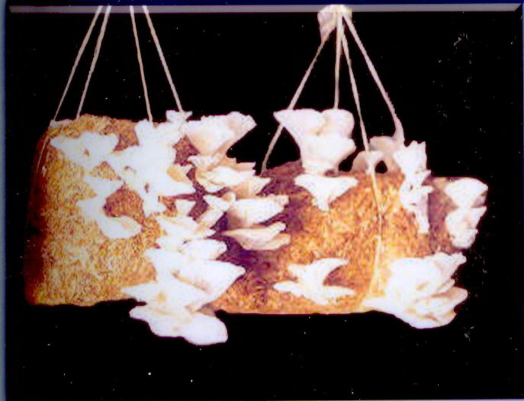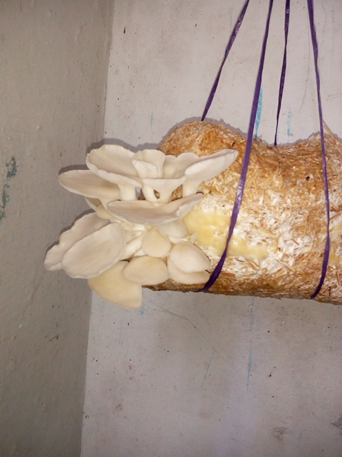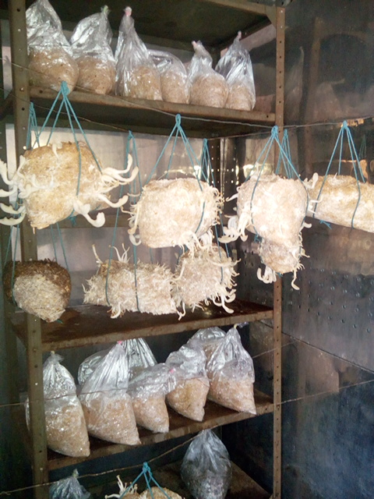Spawn run in Polybags

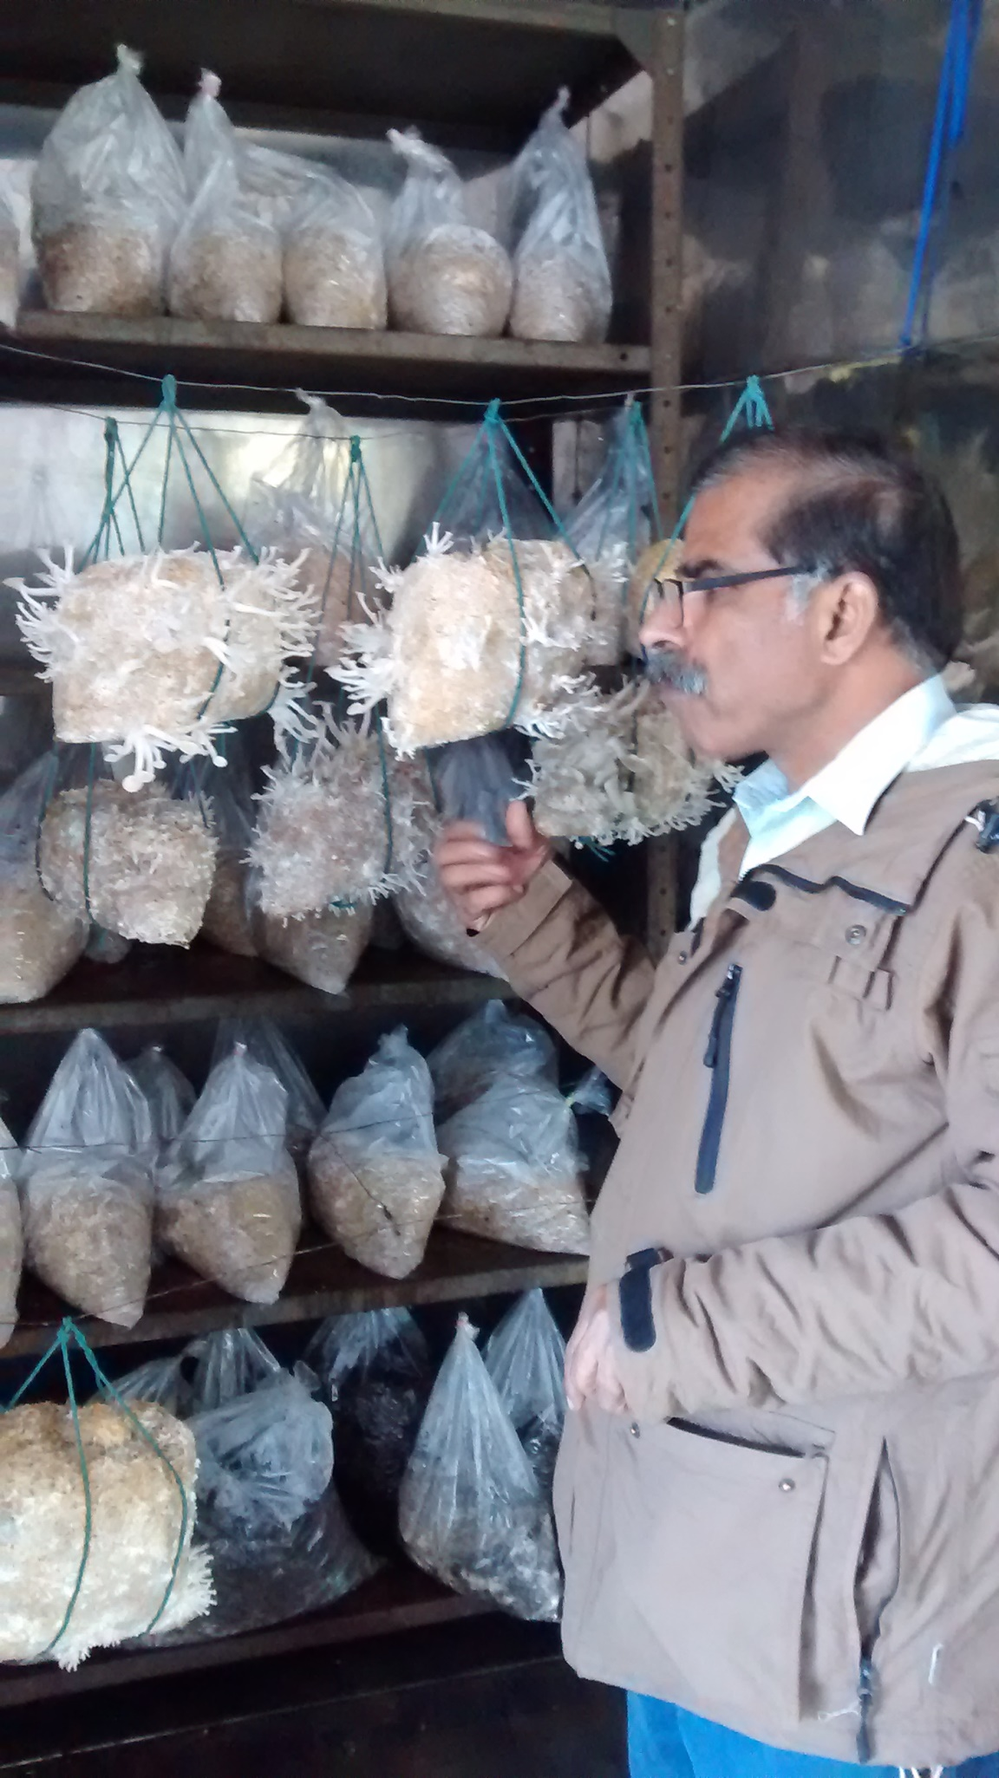Pinhead appearance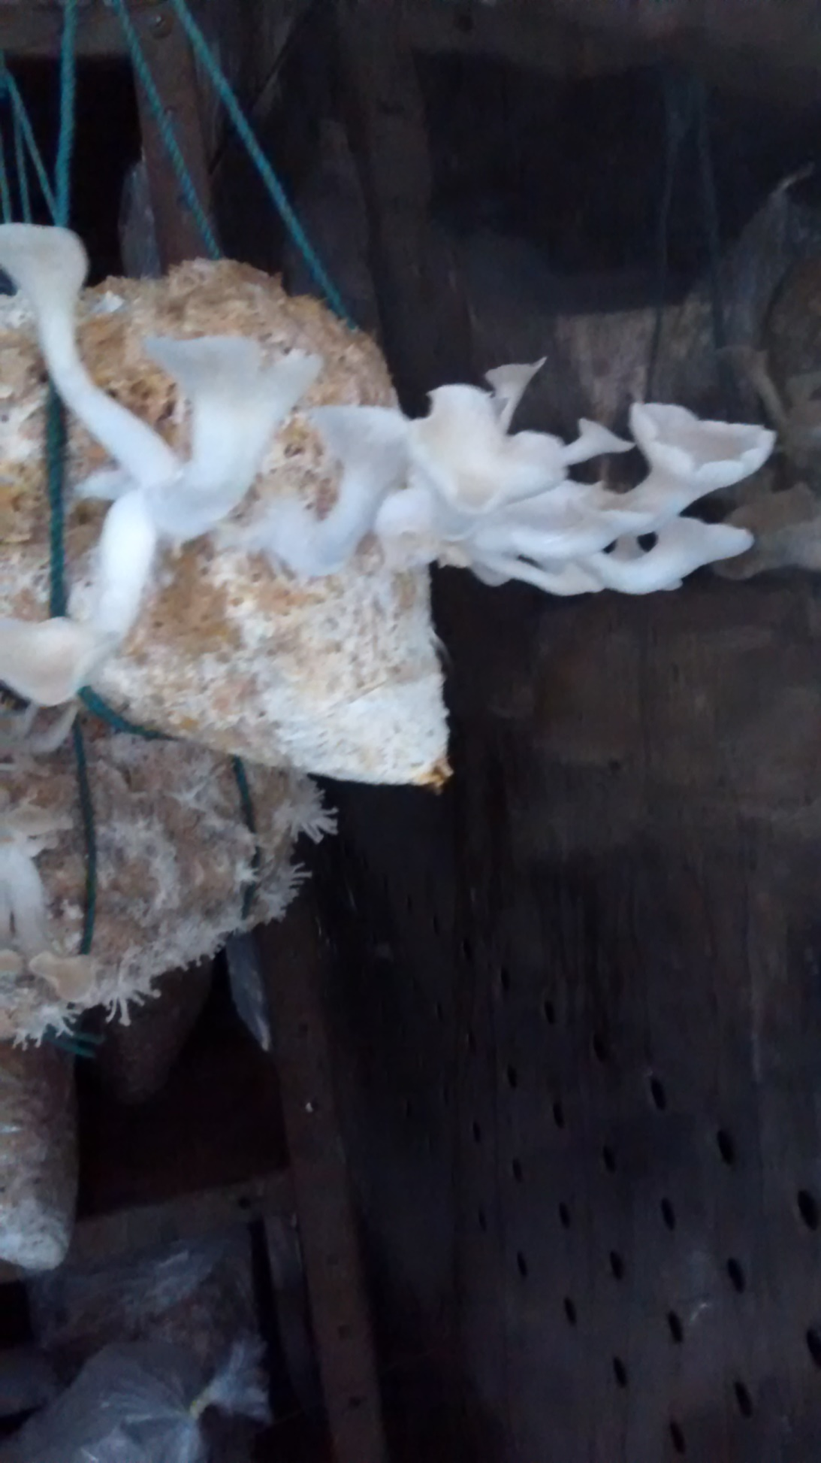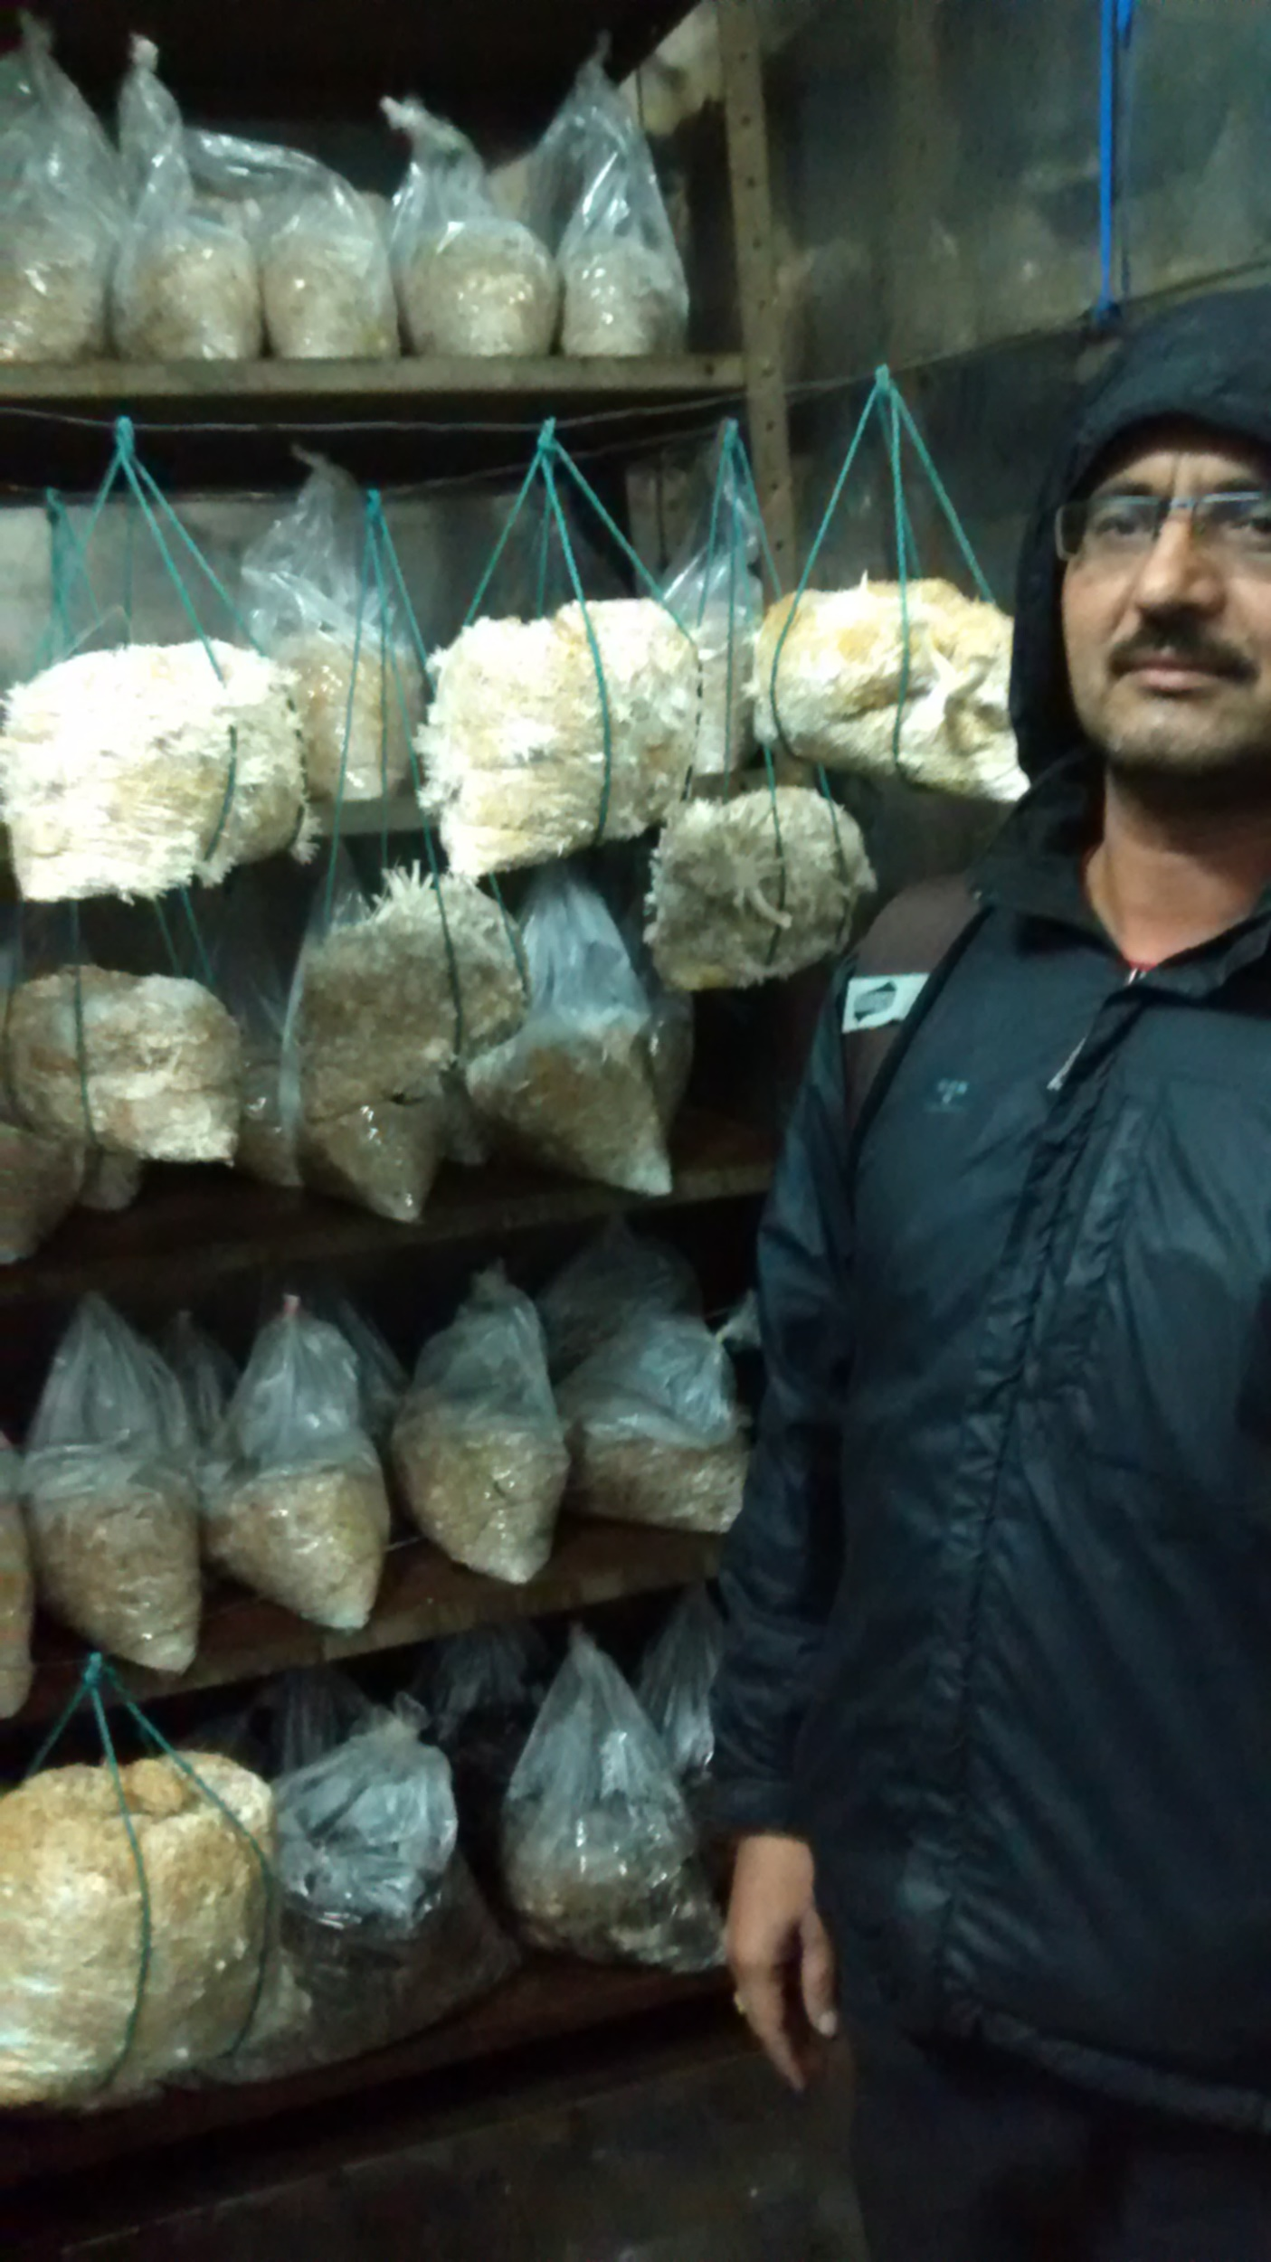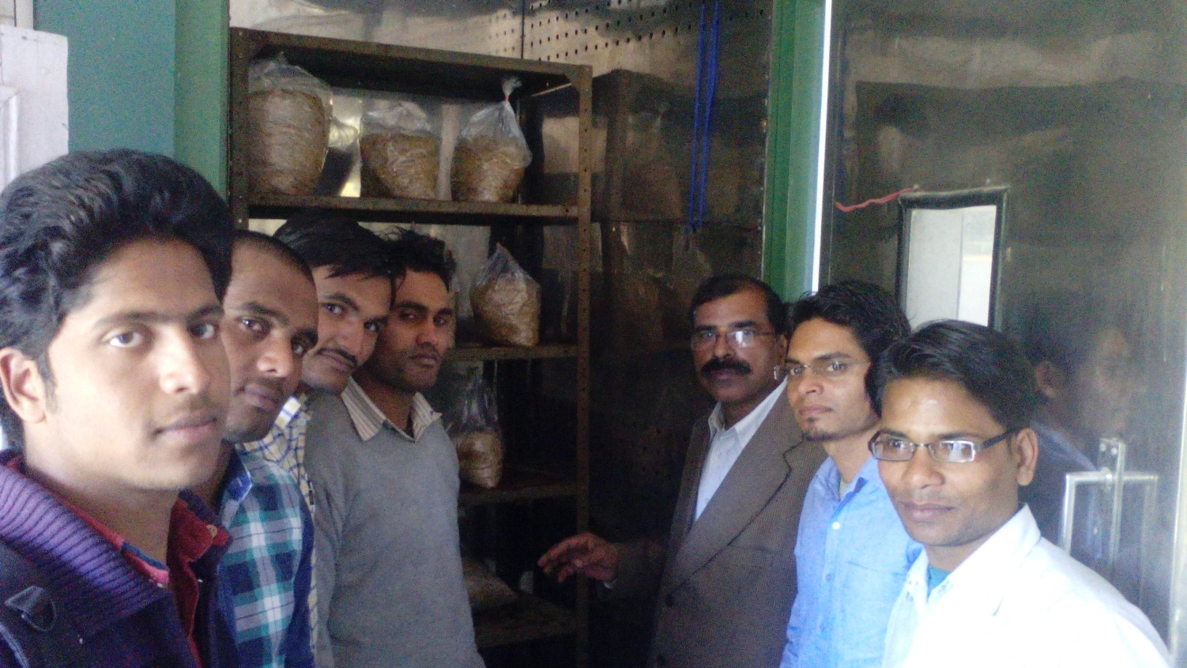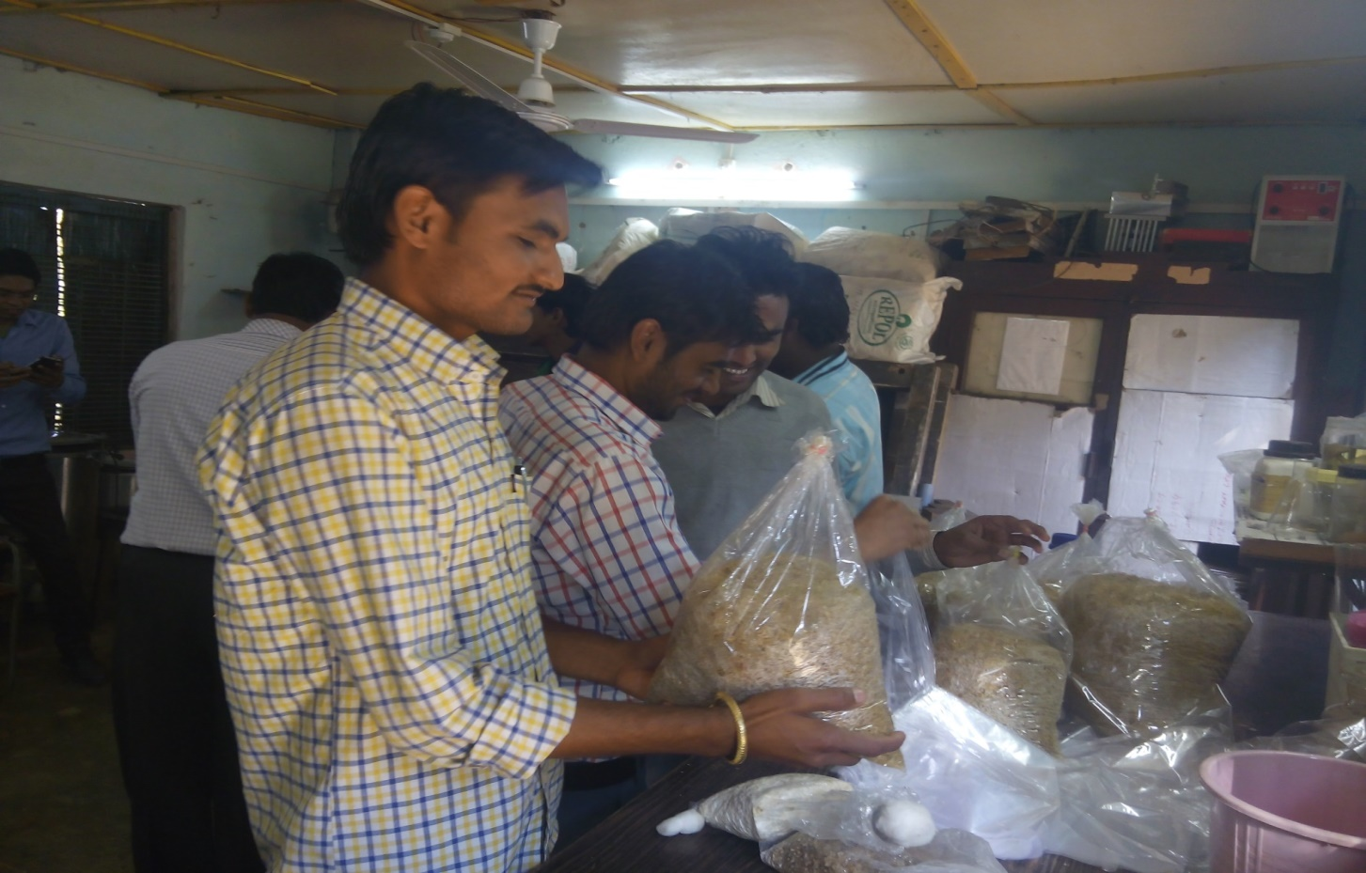Bag Preparation in Lab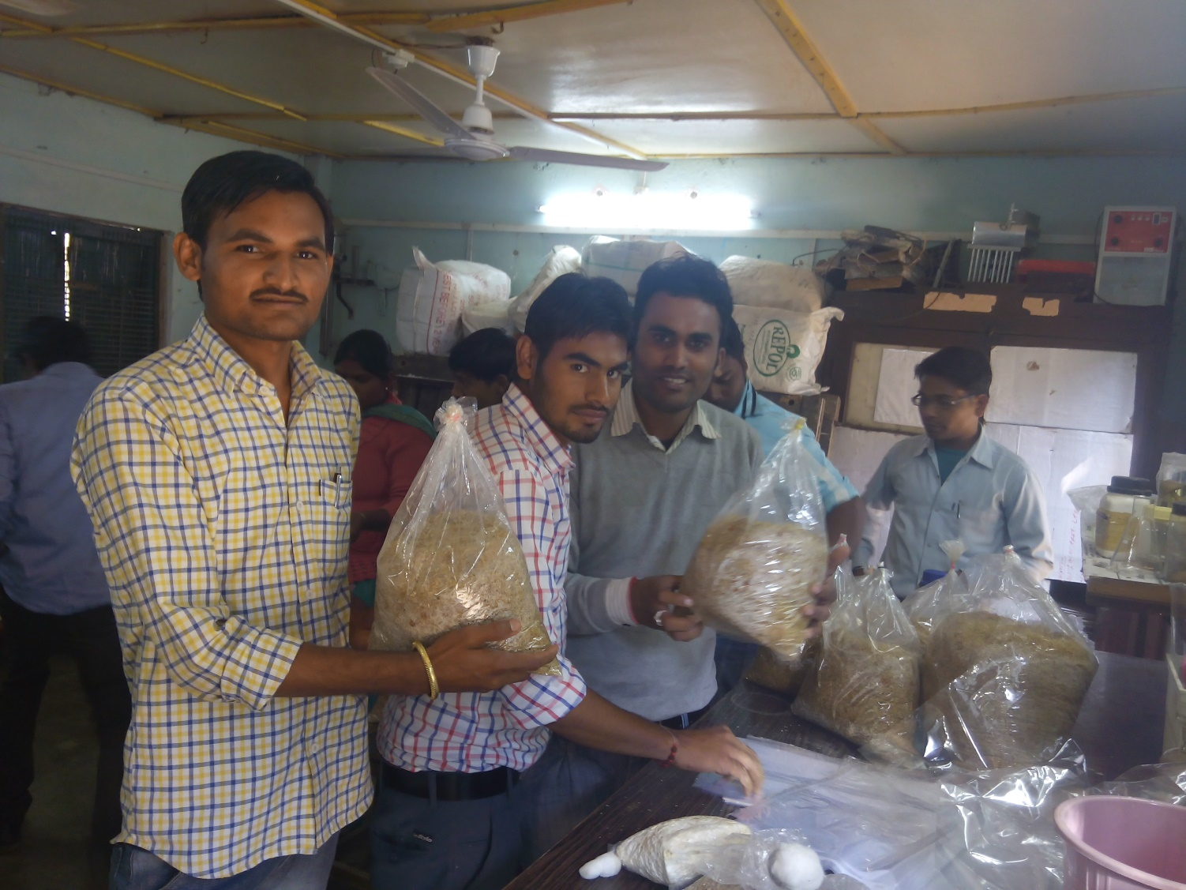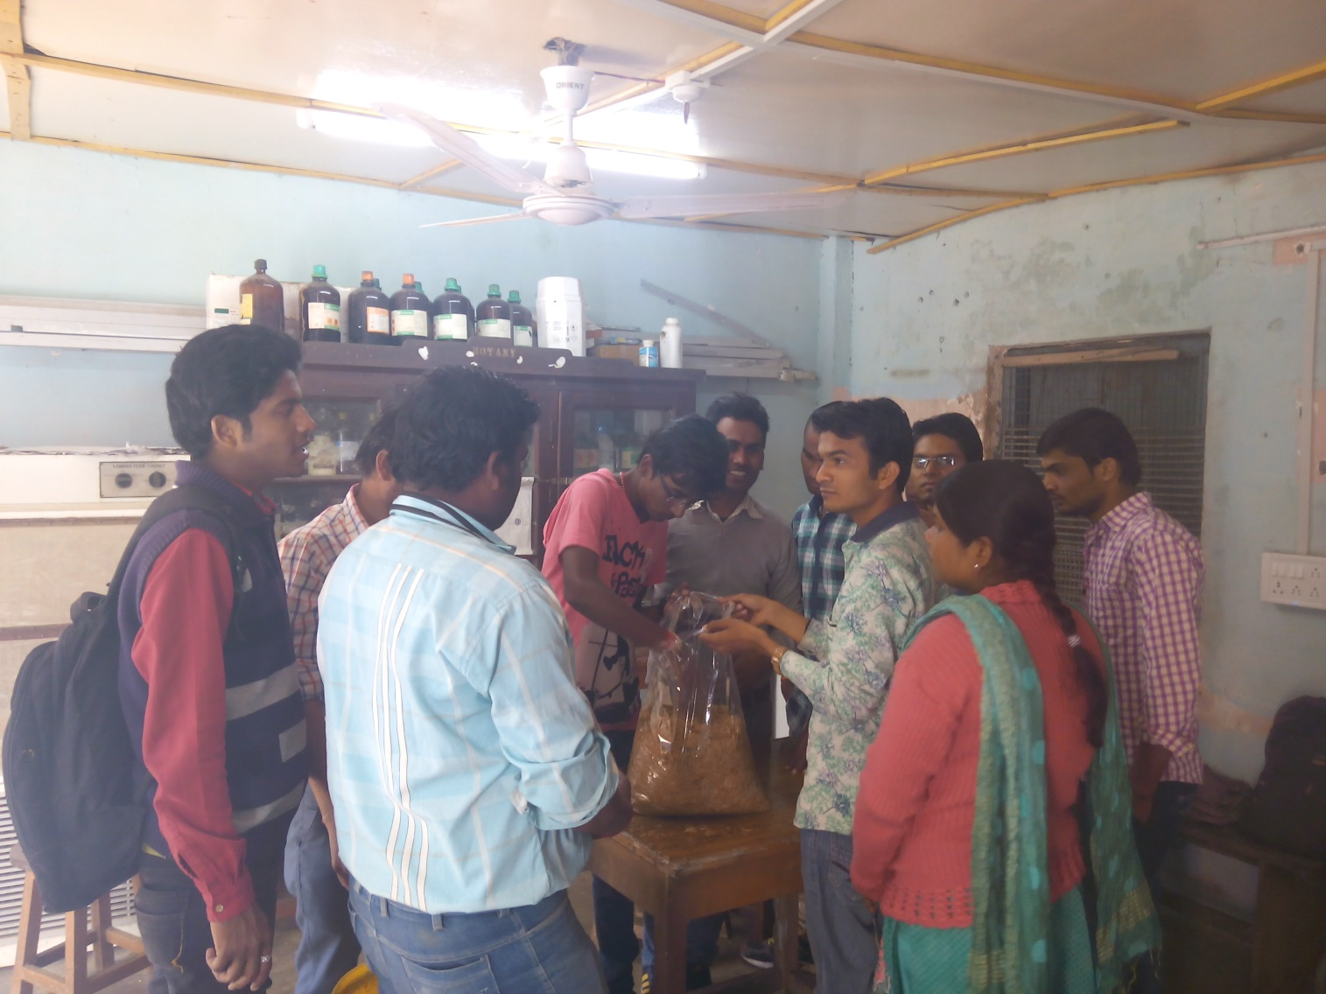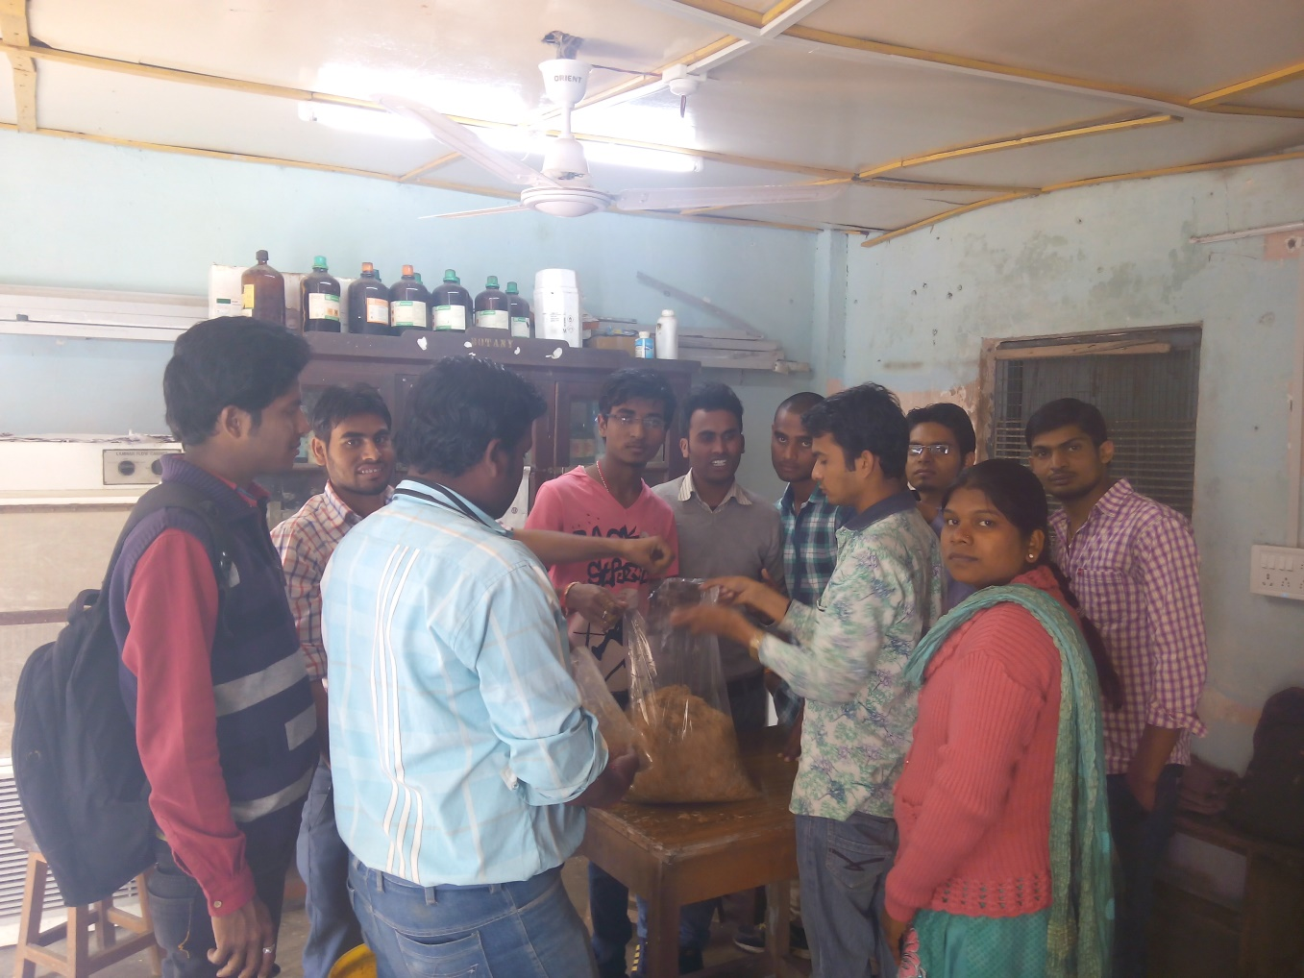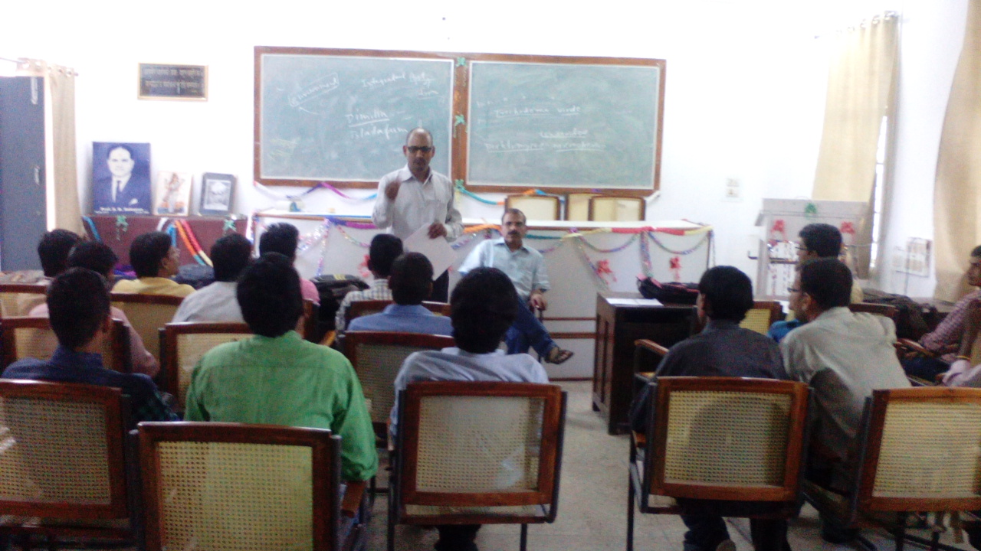Workshop on Mushroom Cultivation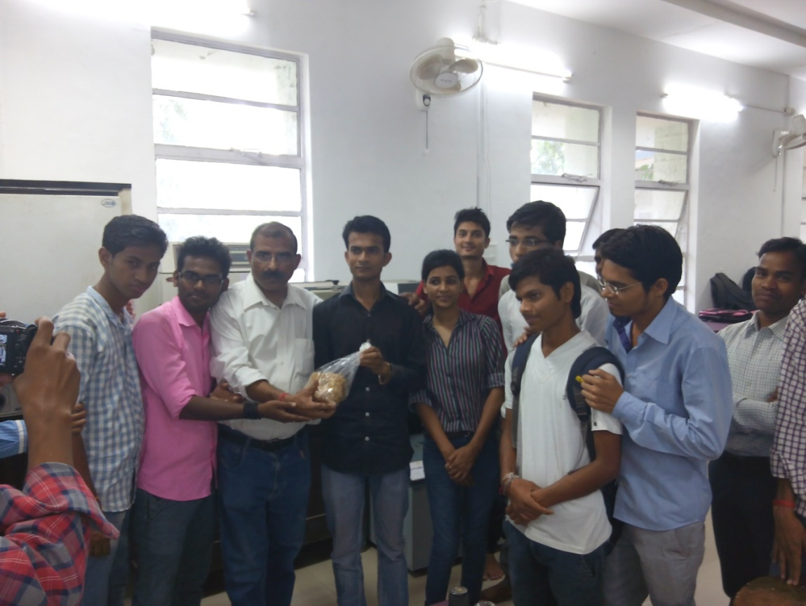Training to PG Students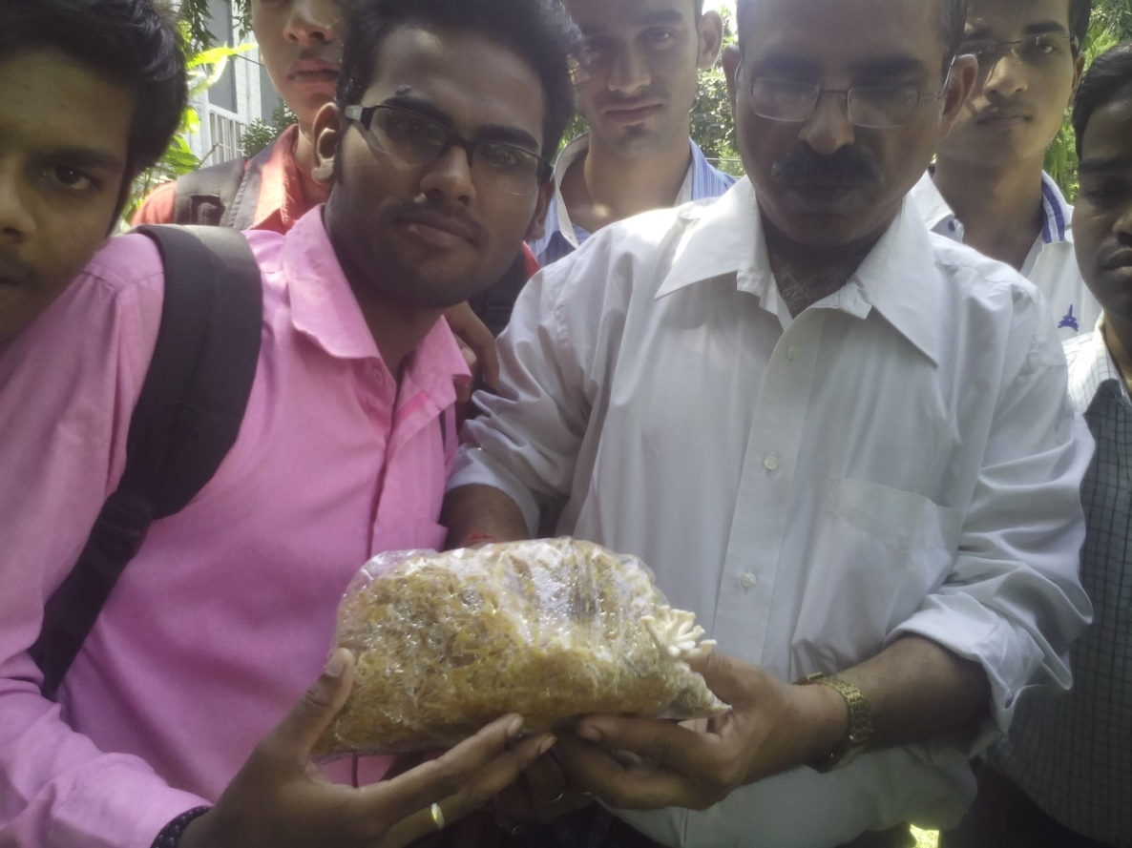

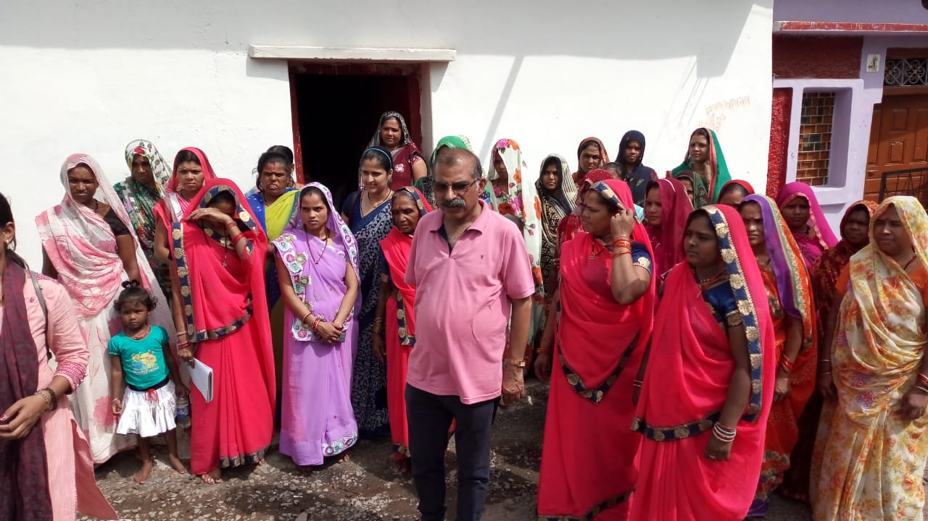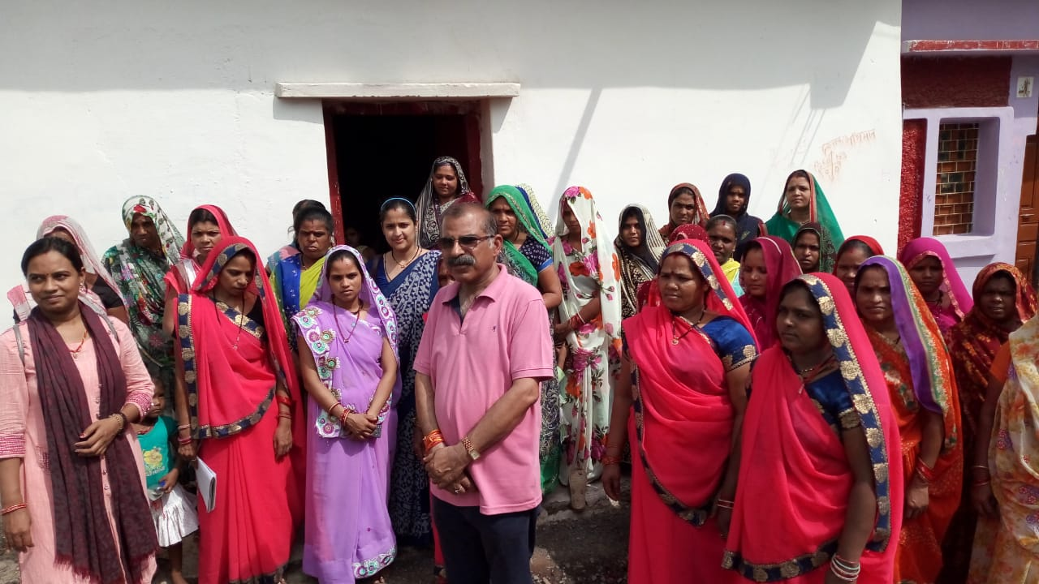Training to Women of Patharia Villege

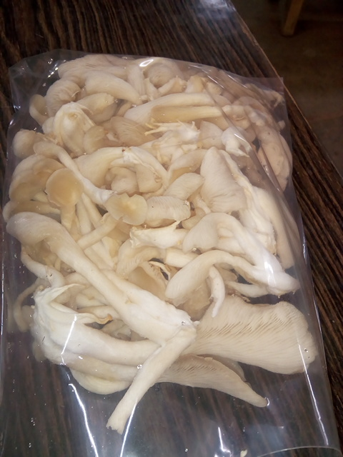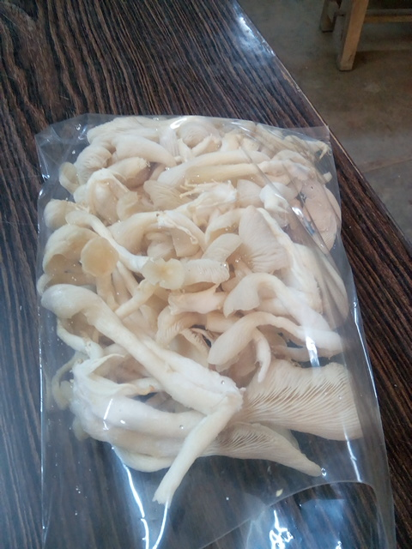

Ready for Processing