**A short excursion to the rangir Forest**

# Dr. Harisingh Gour University Sagar M.P.

**Department of Botany**

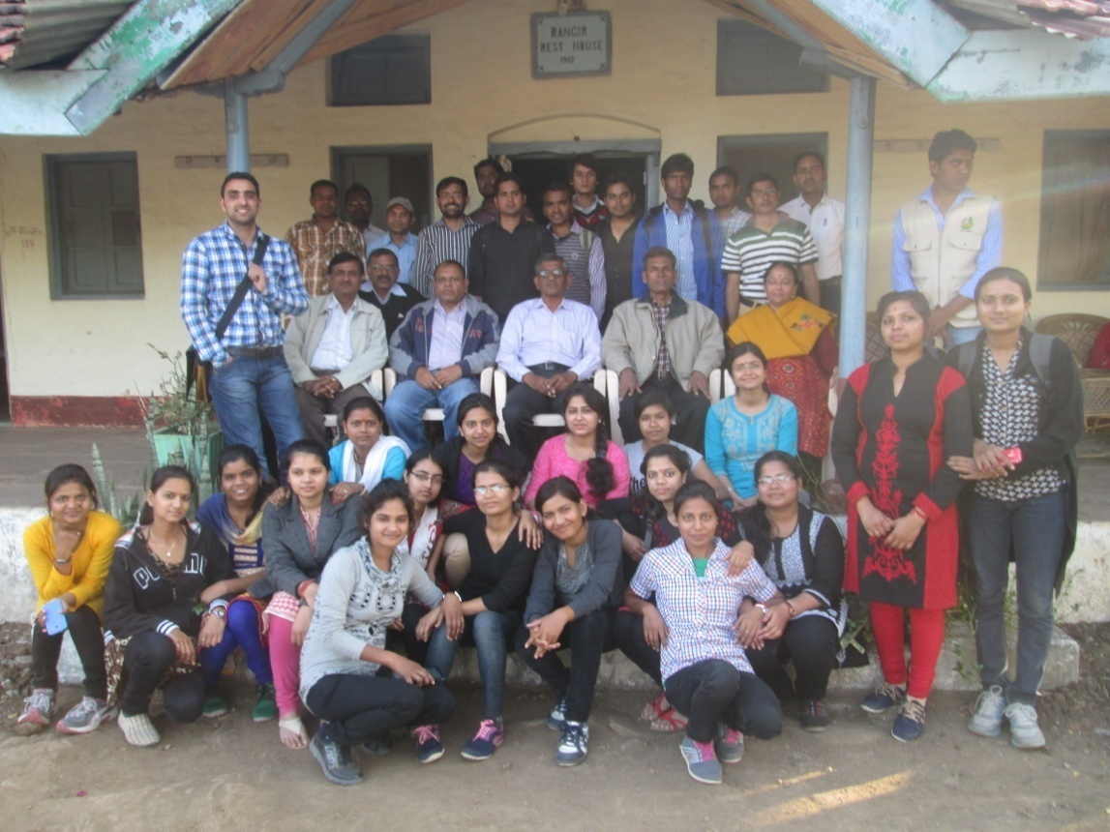

**Submitted To**

**Prof. Achana Mehta**

**Submitted By**

**Dinesh Malasiya**

**M.Sc. IV Sem.**

**INTRODUCTION :**

The main aim of excursion for students and institutions holding documented collections of living plants for the purposes of scientific research, conservation, display and education which meet :

1. Reasonable degree of performance,
2. Underlying scientific basis for the collection,
3. Proper documentation of the collections, including wild origin,
4. Monitoring of the plant in the collections,
5. Adequate labeling of the plants,
6. Open to the public,
7. Communication of information to other forests,
8. Exchange of seed or other materials,
9. Undertaking of scientific or technical research on plants in the collection, and
10. Maintenance of research programs in plant taxonomy in associated herbaria.

**OBJECTIVE :**

The excursion aimed to introduce the students to botanical collections, activities, conservation, functions and to introduction about the different types of forests, species of plants, ecological interaction between them, collection of seeds, bulbs, tubers for their re-plantation and sustainable utilization. So every student of Botany should go for short or long excursion during his study time.

**ABOUT THE JOURNEY :**

The excursion of students of M.Sc. II & IV sem and Ph.D scholars, Department of Botany, Dr. H.S. Gour University, Sagar (M.P.) was started from the department on 14/02/2015 at 08:10 AM. TWO bus were arranged for the excursion. The total number of students were 32 with six professors namely Prof. A.N. Rai, Prof. S.K. Yadav, Prof. P. Khare, Prof. D. Vyas, Prof. M.L. Khan, Prof. A. Mehta we reached Nainagiri near about 11.00 AM. After entering in the forest Prof. P. Khare introduce firstly about the forest and local plant species and ecological interaction of plant and environment. After that Prof. A.N.. Rai introduce about the fungal plant disease found on the plant of the forest.

In forest ecosystem two hours we were continuously interact with the different plant species and fungal pathogen which affect the plant. At 1:00 PM we were take a lunch at Jain Temple Bhojnalaya and take a rest. After rest we entered in forest which is a part of Nainagiri forest range. We collect a lot of plant material for herbarium deposition in the Department. At 4:00 PM we started the returned journey of our excursion and reach near about 6:00 PM to department.

**ABOUT THE NANINAGIRI FOREST**

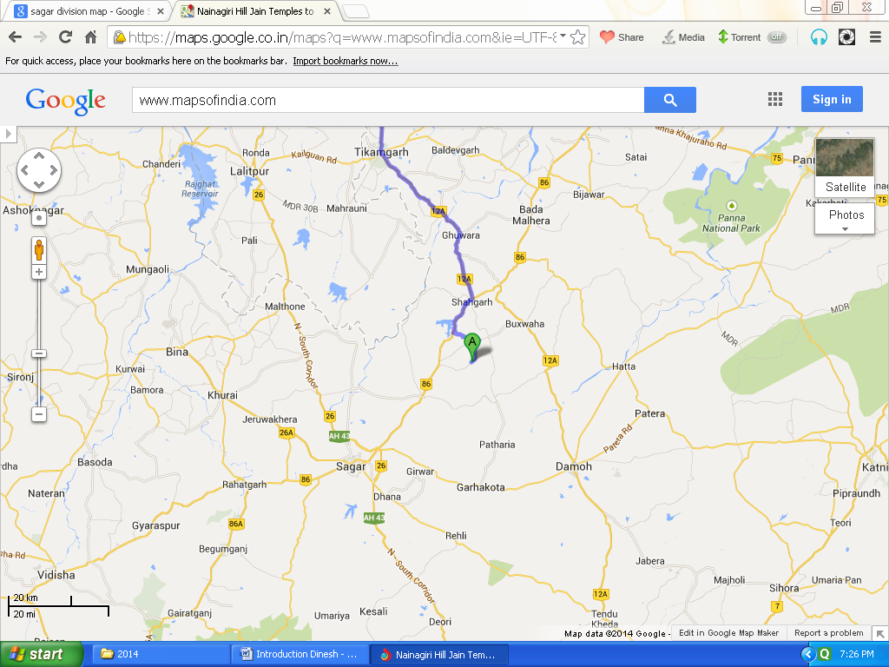

**Nainagiri**

The area of excursion was near about 55km in North-east direction from Sagar city. This forest is located in Chattarpur District. Area is widely known for its rich forest plant species diversity and is commonly called as Nainagiri forest.

The Nainagiri forest is properly called as Central Indian dry deciduous forest (Teak dominant forest).

**LIST OF PLANT SPECIES OBSERVED IN NAINAGIRI FOREST**

**Dominant Species**

|  |  |  |  |
| --- | --- | --- | --- |
| **S. No.** | **Local Name** | **Botanical Name** | **Family** |
| 1 | Saaj | *Terminalia Tomentosa* | Combretaceae |
| 2 | Semal | *Bombax ceiba* | Fabaceae |
| 3 | Palas | *Butea moosperma* | Fabaceae |
| 4 | Saagon | *Tectona grandis* | Verbenaceae |
| 5 | Bel | *Aegle marmelos* | Rutaceae |
| 6 | Mahua | *Madhuca latifolia* | Sapotaceae |
| 7 | Amaltas | *Cassia fistula* | Fabaceae |
| 8 | Tendu | *Diospyros melanoxylon* | Ebenaceae |
| 9 | Chironji | *Buchanania lanzan* | Anacardiaceae |
| 10 | Reonja | *Acacia leucophloea* | Fabaceae |
| 11 | Jamrasi | *Elaodendron glucum* | Celastrineae |
| 12 | Chirol | *Holoptelia integrifolia* | Ulmaceae |
| 13 | Papra | *Gardenia latifolia* | Rubiaceae |
| 14 | Seja | *Lagerstroemia parviflora* | Lythraceae |
| 15 | Babul | *Acacia nilotica* | Mimosaceae |
| 16 | Kher | *Acacia catechu* | Mimosaceae |
| 17 | Teak | *Tectona grandis* | Verbinaceae |
| 18 | Haldu | *Adena cardifolia* | Rubiaceae |
| 19 | Gunja | *Lienea coromandilica* |  |
| 20 | Dhavara | *Anogoissus latifolia* |  |
| 21 | Kanker | *Flacortia indica* | Flacortiaceae |
| 22 | Kachnar | *Bauhinia variegata* | Fabaceae |
| 23 | Kardai | *Anogeissus pendula* | Combretaceae |
| 24 | Kulu | *Sterculia urens* | Sterculiaceae |
| 25 | Arjun | *Terminalia arjuna* | Combretaceae |

**Herb Species**

|  |  |  |
| --- | --- | --- |
| **S. No.** | **Botanical Name** | **Family** |
| 1 | *Anisomeles* | Lamiaceae |
| 2 | *Xanthium strumarium* | Asteraceeae |
| 3 | *Solanum xanthocarpum* | Solanaceae |
| 4 | *Evolvulus alsinoides* | Convolvalaceae |
| 5 | *Dichanthium sericeum* | Poaceae |
| 6 | *Cyperus rotundus* | Cyperaceae |
| 7 | *Setaria glauca* | Poaceae |
| 8 | *Eragrostis* | Poaceae |
| 9 | *Emilia sonchifolia* | Asteraceae |
| 10 | *Idigofera* | Fabaceae |
| 11 | *Ageratum conyzoides* | Astercaceae |
| 12 | *Asterocantha longifolia* | Acanthaceae |
| 13 | *Fimbristylis dichotoma* | Cyperaceae |
| 14 | *Loranthus (epiphyte)* | Loranthaceae |

**Shrub Species**

|  |  |  |  |
| --- | --- | --- | --- |
| **S. No.** | **Local Name** | **Botanical Name** | **Family** |
| 1 | Ghont | *Zizyphys xylopyra* | Rhamnaceae |
| 2 |  | *Zizyphus moritiana* | Rahmnaceae |
| 3 | Baingli katili | *Solanum xanthocarpum* | Solanaceae |
| 4 |  | *Solanum delcamara* | Solanaceae |
| 5 | Kanker | *Flacourtia indica* | Salicaceae |
| 6 | Karonda | *Carrisa spinarum* | Apocynaceae |
| 7 |  | *Holarrhena antidysenterica* | Apocynaceae |